Ideation Phase

Define the Problem Statements

|  |  |
| --- | --- |
| Date | 21 October 2022 |
| Team ID | PNT2022TMID38157 |
| Project Name | Smart farmer-IOT Enabled Smart Farming Application |

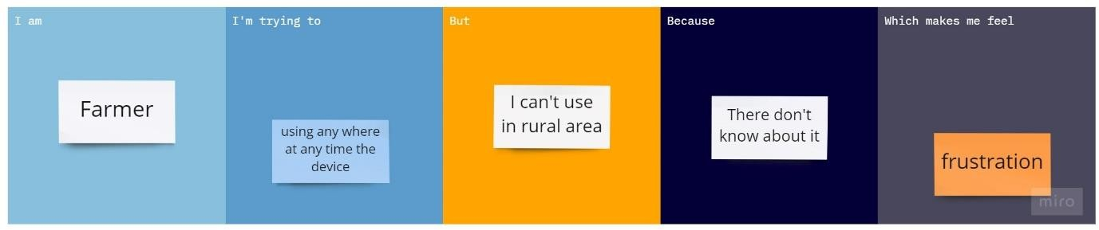

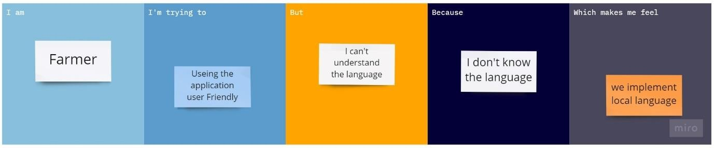

|  |  |  |  |  |  |
| --- | --- | --- | --- | --- | --- |
| **Problem**  **Statement**  **(PS)** | **I am**  **(Customer)** | **I’m trying to** | **But** | **Because** | **Which makes me feel** |
| PS -1 | Farmer | Use this IOT  device | I can’t | I don’t know  how to use | Feel bad |
| PS-2 | Farmer | Use the  application | It was  hard | I don’t know  the language | Frustration |